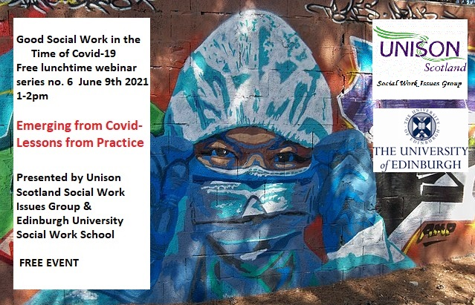

This is the sixth in our lunchtime webinar series that examines current issues in social work practice in Scotland from a critical and radical perspective.
On June 9th 1.00pm to 2.00pm we will explore themes for social workers and students in Scotland relating to good practice in a safe environment - lessons learned from Covid-19. The pandemic has witnessed the best of creative practice but also exposed issues relating to worker safety, isolation and support. Its been a tough year for everyone. Our speakers are: Gillian Ferguson, Learning & Development Advisor from the SSSC ( Scottish Social Services Council), Lindsay McLaughlin, children and family social worker North Ayrshire Council, and a Unison speaker from Scotland's Social Work Issues Group. The speakers will leave time for questions and answers. Please join us and register today!
The event will take place through Microsoft Teams and the link will be sent out to all who register.
ALL WELCOME – PLEASE REGISTER THROUGH EVENTBRITE
https://www.eventbrite.co.uk/e/good-social-work-in-the-time-of-covid-19-lunchtime-webinar-series-no6-tickets-155784065333

